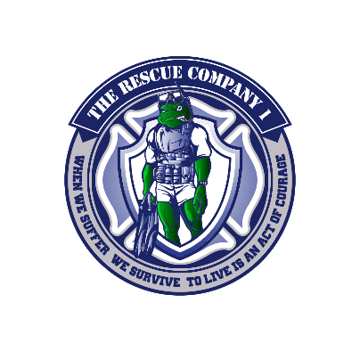
SAR Exam 5
- In a water rescue, the most obvious hazard is?
- Wildlife
- Speed of Water
- Water itself
- Cold water
- The ______ issues of water rescue, and in particular flood events, must also be taken into consideration.
- Water Speed
- Hazmat
- Water temperature
- Time of Day
- Personal protective equipment (PPE) must protect the wearer from the water itself and contact with it.
- Water itself
- Hazmat
- Cold water
- None of the above
- A dry suit fulfills this purpose.
- Flame protection
- A barrier is required between people and the hazardous material
- Cold protection
- Increase in swim speed
- A dry suit will fit a range of people if the seals fit effectively.
- Zippers can close
- Feet are the same size
- Labeled correctly
- Seals fit effectively
- A dry suit __________ offers a barrier but no impact protection or thermal properties.
- Anterior
- Posterior
- Membrane Surface
- Shell

- A dry suit requires additional _______ to be worn underneath
- Sweat protection
- Dry clothing
- Long underwear
- Thermal Clothing
- Wetsuits work by trapping a layer of water between the individual's skin and the suit material to?
- To warm the water
- To help with flotation
- To reduce water drag
- None of the above
- While wetsuits can be a good option for rescue teams when operating in clean rivers, they are not suitable for?
- Flood environment
- Air operations
- Long distance
- Deep dives
- It is important to note that in the United States, the term PFD is used in common usage to denote both lifejackets and buoyancy aids.
- False
- True
- In water rescue anyone near 15 feet from water’s edge need to have a PFD.
- False
- True
- What statement is true about Testing a Flotation Device
- Try it on and fasten all the buckles and straps. Make sure you can breathe easily.
- If you can pull it over your head, it's too big. If you cannot fasten all the buckles and straps comfortably, it's too small.
- With supervision, enter the water and float on your back. Make sure your chin clears that water so that you can breathe. If your chin/mouth is underwater, you need more flotation.
- Try swimming on your front and back. Make sure you can move well enough and that your PFD or lifejacket does not float up around your face. If so, it is too big.
- Only the first and third
- The first three
- All the above
- None of the above
- Type V PFDs - for those whose primary mandate is rescue from Swiftwater
inherently buoyant, minimum buoyancy of 15.5 lbs, at least 2 cinch straps to ensure PFD stays in place in swiftwater, cinch-type strap and closure at the waist of the PFD, and quick-release system for tethering or towing.
- True
- False

- Lifejackets are designed for accidental immersion.
- True
- False
- Lifejackets are intended to provide buoyancy and to maintain the body in a position that protects the airway.
- Head
- Back
- Airway
- None of the above
- The NFPA sets standards for helmets for surface water operations in the 1952 Standard.
- These helmets are designed to protect the head from impacts.
- Must Float
- Must be yellow
- A & B
- The NFPA specifies a cut-proof wrist in Swiftwater gloves
- True
- False
- Swiftwater environments often have high levels of background noise created by moving water, and in many cases whistle blasts can be heard when vocal communication is not possible.
- Radio
- Whistle
- Flashlight
- Megaphone
- Anyone working near the water environment with ropes must carry a?
- Radio
- Name tag
- Knife
- Lifeguard Style Float
- Swim fins can greatly increase a rescuer's speed when swimming in water. However, they can be difficult and tiring to use in swiftwater and are awkward when moving about on shore.
- False
- True

